**Title :** YumFood : a website for foodies.

**Abstract**

We have created a website Yumm Food and deployed the website on cloud. Cloud services such as EC2, S3 and CloudFront have been used. Amazon Simple Storage Service (Amazon S3) is object storage with a simple web service interface to store and retrieve any amount of data from anywhere on the web. Amazon Elastic Compute Cloud (Amazon EC2) is a web service that provides secure, resizable compute capacity in the cloud. It is designed to make web-scale cloud computing easier for developers. Amazon CloudFront is a web service that speeds up distribution of your static and dynamic web content, such as .html, .css, .php, and image files, to your users.

**Introduction**

Our application is a restaurant website which gives details about YumFood. The user can get the details about various food items in just one click. Also, user can give review of their own experience at Yum Food in the comments column.

The services used have following features :

S3 -

Simple

Durable

Scalable

Secure

Available

Low Cost

Simple Data Transfer

Integrated

Easy to Manage

EC2 -

Elastic Web-Scale Computing

Completely Controlled

Flexible Cloud Hosting Services

Integrated

Reliable

Secure

Inexpensive

CloudFront -

Dynamic Content

Management Console

Support for POST/PUT and other HTTP Methods

Custom SSL

Custom Error Responses

Zone Apex Support

**Implementation details**

For Development, We’ve used web technologies like HTML, CSS, Javascript, AngularJs for front end. And Nodejs, Mongodb as backend.

After Development, We are deploying it to the cloud. We are using Amazon Web Services.

When we go to domain name, i.e., [https://d3oeva3du0kmva.cloudfront.net](https://d3oeva3du0kmva.cloudfront.net/). Route 53 is activated.

Route 53 is a highly available and scalable cloud Domain Name System (DNS) web service. It is designed as extremely reliable and cost effective way to route end users to Internet applications by translating names like www.example.com into the numeric IP addresses like 192.0.2.1 that computers use to connect to each other. Amazon Route 53 is fully compliant with IPv6 as well. Amazon Route 53 effectively connects user requests to infrastructure running in AWS – such as Amazon EC2 instances, Elastic Load Balancing load balancers, or Amazon S3 buckets.

Amazon S3 provides HTTP web-serving capabilities, and the content can be viewed by any browser. You also need to configure Amazon Route 53, a managed Domain Name System (DNS) service, to point http://example.com to your Amazon S3 bucket. Following is the diagram,

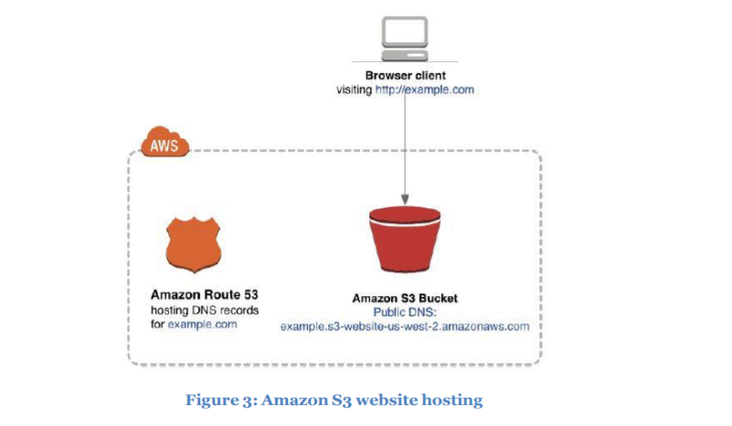

**Evolving the Architecture with Amazon CloudFront** - When it comes to websites, speed matters. Web visitors enjoy and expect a fast browsing experience. Even slight page-loading delays can hurt business. In today’s global economy, your site needs to be responsive and deliver page loads with low-latency. Major search engines penalize slow websites by burying their search results.

The Amazon CloudFront content delivery web service integrates with other AWS products to give you an easy way to distribute content to users with low latency, high data transfer speeds, and no minimum usage commitments. To reduce latency and provide a better user experience, use Amazon CloudFront. Amazon CloudFront is a content delivery network (CDN) that uses a global network of edge locations for content delivery. A side benefit is that CloudFront also provides reports to help you understand how users are using your website.

**Snapshot**

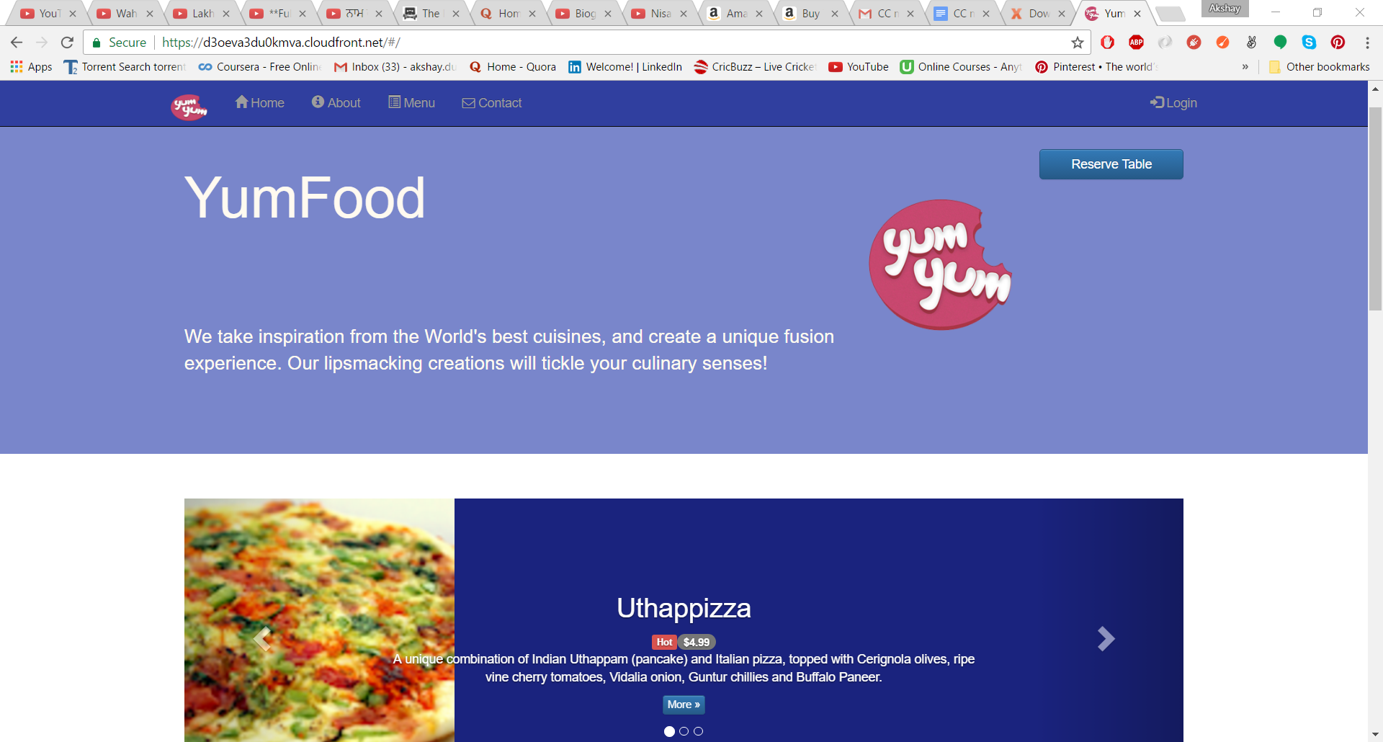

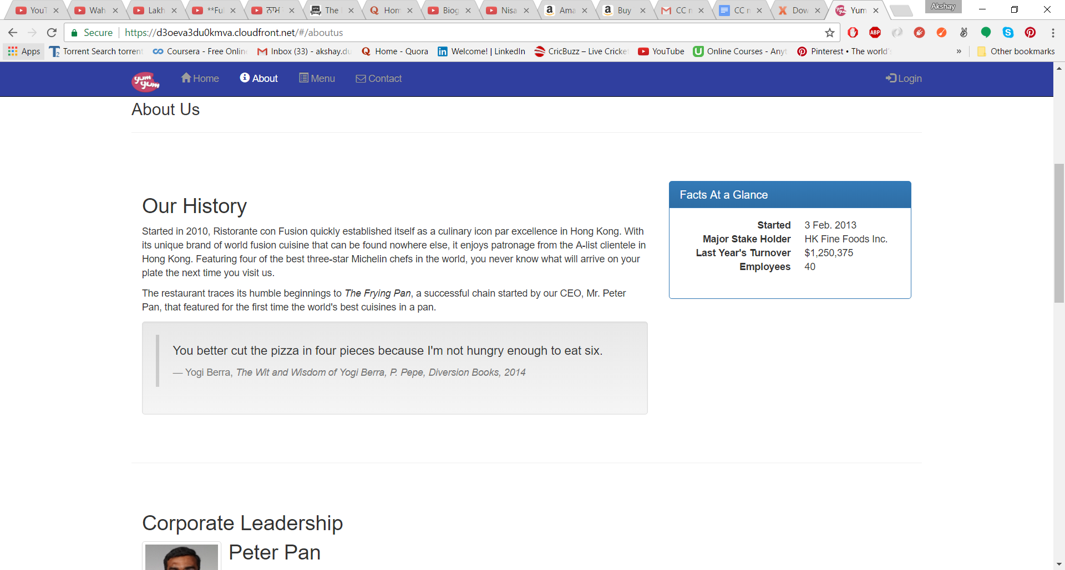

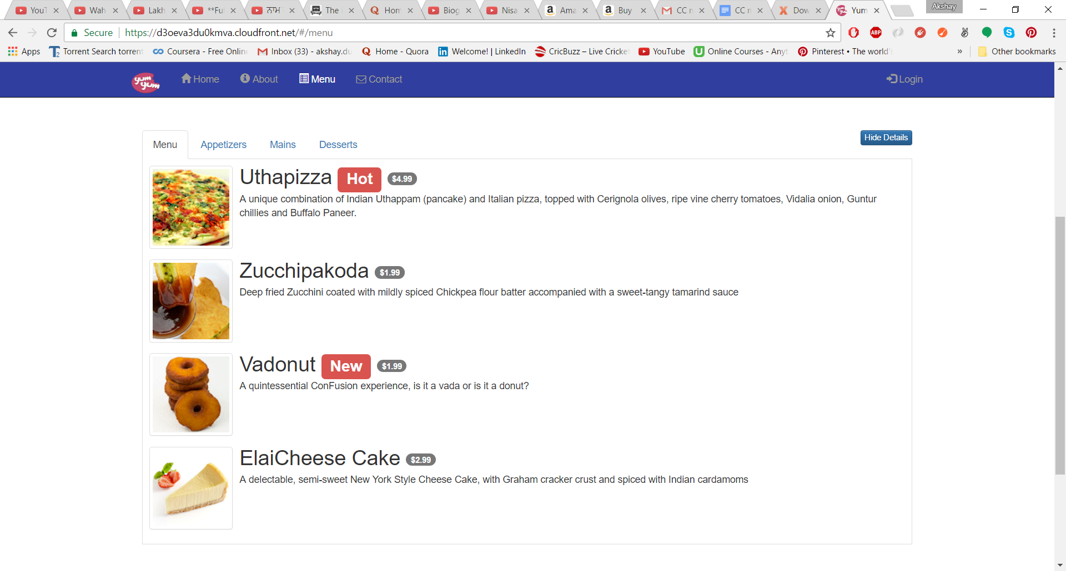

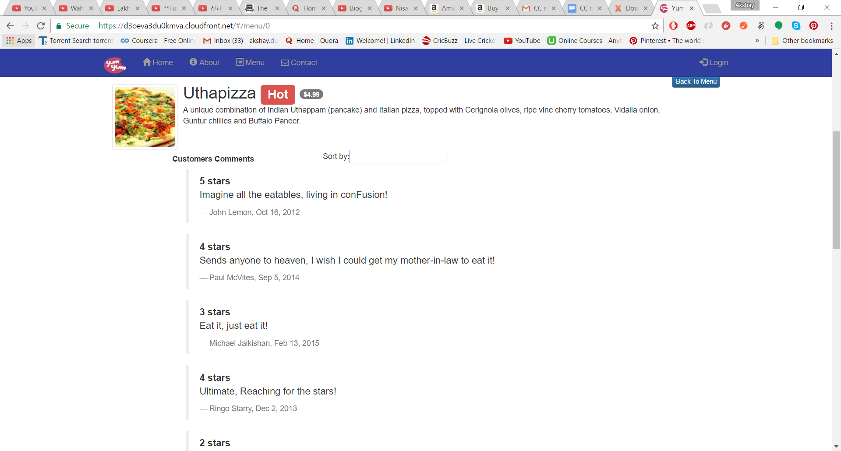

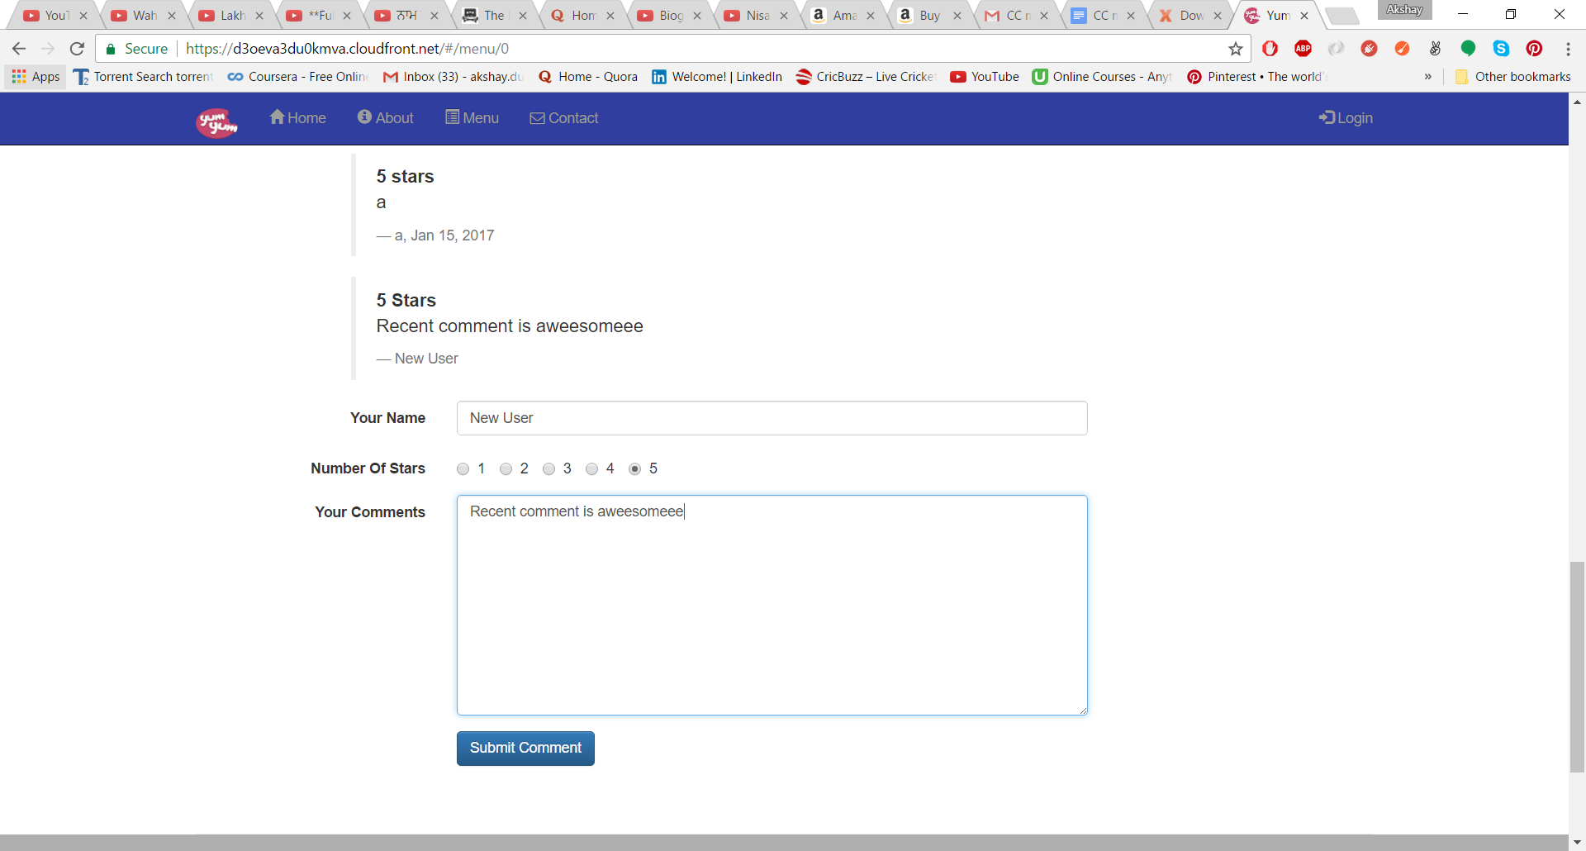

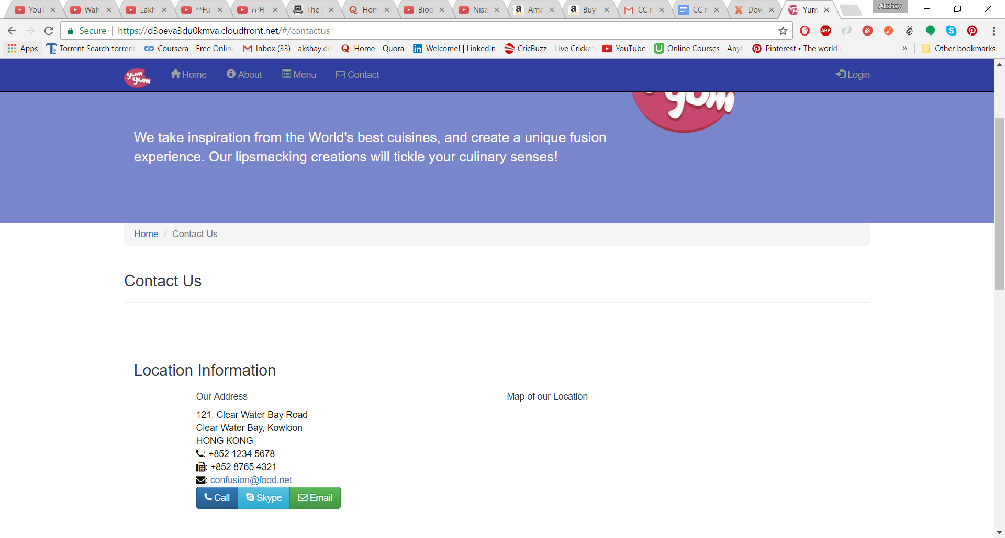

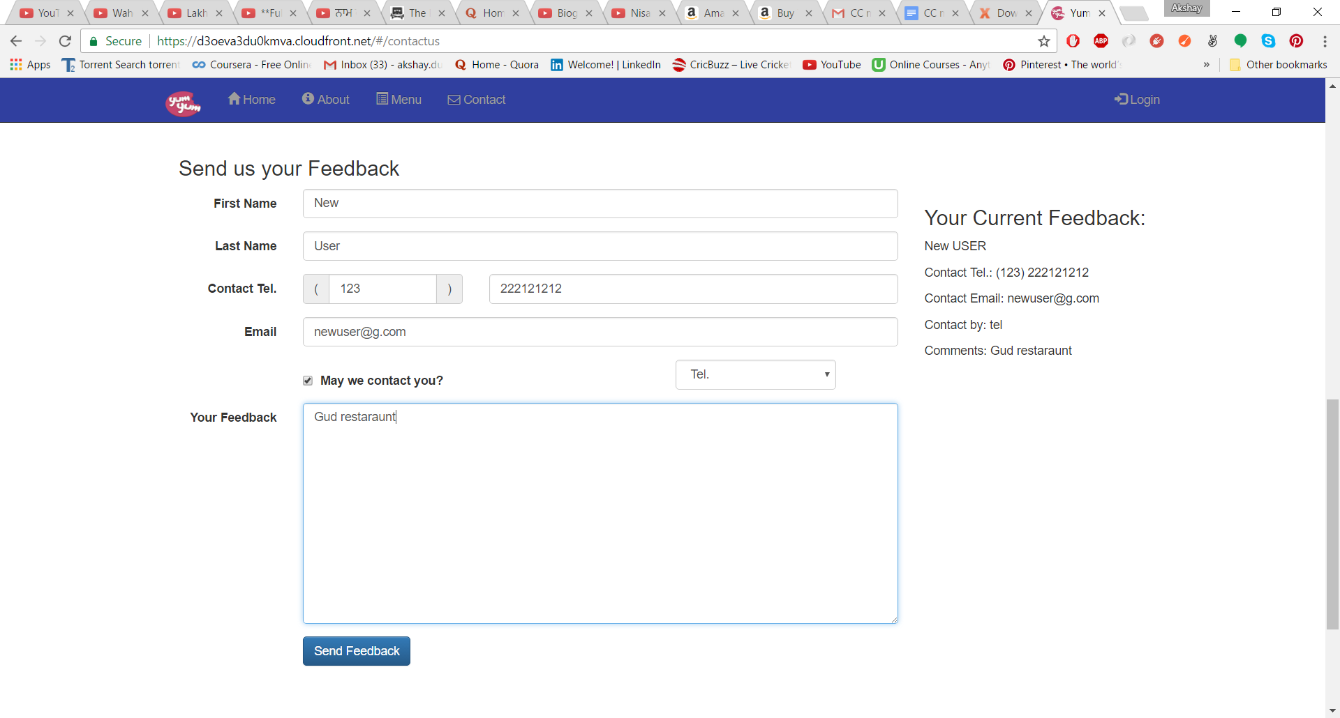

**Conclusion**

Hence, we have successfully studied benefits of cloud services like, Amazon S3. We also studied how the DNS System like Amazon Route 53 works with Content Delivery Network like Amazon Cloud Front. We created virtual buckets of the packets of data.

**References**

https://aws.amazon.com/s3/

<https://aws.amazon.com/ec2/>

https://aws.amazon.com/cloudfront/